NUMBER GUESSING GAME USING PYTHON

AIM:
To design and develop an interactive Number Guessing Game using Python Tkinter that allows players to guess a randomly generated number within a specified range. The game provides hints such as "Too High" or "Too Low", tracks the number of attempts, and displays a success message when the correct number is guessed. It includes a graphical user interface, restart option, and exit button.

PROCEDURE:
1.Start the program and import the required Python libraries: tkinter and random.
2.Create the main game window using Tkinter and set the title as "NUMBER GUESSING GAME".
3.Design a graphical interface with a heading, instructions, and an input field for entering the guessed number.
4.Generate a random number between 1 and 100 using the random module.
5.Allow the player to enter a number in the input field.
6.Create a GUESS button to check whether the entered number is correct.
7.Compare the guessed number with the randomly generated number.
8.Display "Too Low" if the guessed number is smaller than the target number.
9.Display "Too High" if the guessed number is greater than the target number.
10.Display a success message when the correct number is guessed and show the total number of attempts.
11.Provide RESTART GAME and EXIT buttons to restart the game or close the application.
12.Execute the program and verify number generation, hints, attempt counting, and restart functionality.
PROGRAM CODE:
import tkinter as tk
import random

# Game Settings
WIDTH = 400
HEIGHT = 350

class NumberGuessingGame:
def __init__(self, root):
self.root = root
self.root.title("NUMBER GUESSING GAME")
self.root.geometry("400x350")
self.root.configure(bg="#172554")
self.root.resizable(False, False)

tk.Label(
root,
text="NUMBER GUESSING GAME",
font=("Arial Black", 16),
bg="#172554",
fg="white"
).pack(pady=15)

tk.Label(
root,
text="Guess a number between 1 and 100",
font=("Arial", 12),
bg="#172554",
fg="#FACC15"
).pack(pady=5)

self.entry = tk.Entry(
root,
font=("Arial", 16),
justify="center"
)
self.entry.pack(pady=10)

tk.Button(
root,
text="GUESS",
font=("Arial", 12, "bold"),
bg="#22C55E",
command=self.check_guess
).pack(pady=5)

self.message = tk.Label(
root,
text="Enter your guess!",
font=("Arial", 12, "bold"),
bg="#172554",
fg="white"
)
self.message.pack(pady=10)

self.attempt_label = tk.Label(
root,
text="Attempts: 0",
font=("Arial", 12),
bg="#172554",
fg="#FACC15"
)
self.attempt_label.pack(pady=5)

button_frame = tk.Frame(root, bg="#172554")
button_frame.pack(pady=10)

tk.Button(
button_frame,
text="RESTART GAME",
font=("Arial", 10, "bold"),
bg="#38BDF8",
command=self.restart
).pack(side="left", padx=5)

tk.Button(
button_frame,
text="EXIT",
font=("Arial", 10, "bold"),
bg="#EF4444",
fg="white",
command=root.destroy
).pack(side="left", padx=5)

self.restart()

def restart(self):
self.number = random.randint(1, 100)
self.attempts = 0
self.running = True

self.entry.config(state="normal")
self.entry.delete(0, tk.END)
self.message.config(
text="Enter your guess!",
fg="white"
)
self.attempt_label.config(text="Attempts: 0")

def check_guess(self):
if not self.running:
return

try:
guess = int(self.entry.get())

if guess < 1 or guess > 100:
self.message.config(
text="Enter a number from 1 to 100!",
fg="#EF4444"
)
return

self.attempts += 1
self.attempt_label.config(
text=f"Attempts: {self.attempts}"
)

if guess < self.number:
self.message.config(
text="Too Low! Try Again.",
fg="#FACC15"
)

elif guess > self.number:
self.message.config(
text="Too High! Try Again.",
fg="#FACC15"
)

else:
self.message.config(
text=f"Correct! You Won in {self.attempts} Attempts!",
fg="#22C55E"
)
self.running = False

except ValueError:
self.message.config(
text="Please enter a valid number!",
fg="#EF4444"
)

# Main Application
root = tk.Tk()
game = NumberGuessingGame(root)
root.mainloop()

OUTPUT:
When the program is executed, a graphical window titled NUMBER GUESSING GAME appears.
The window displays:

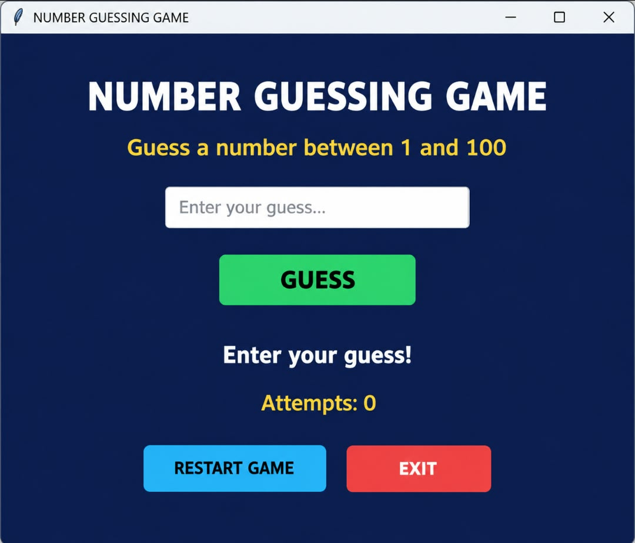
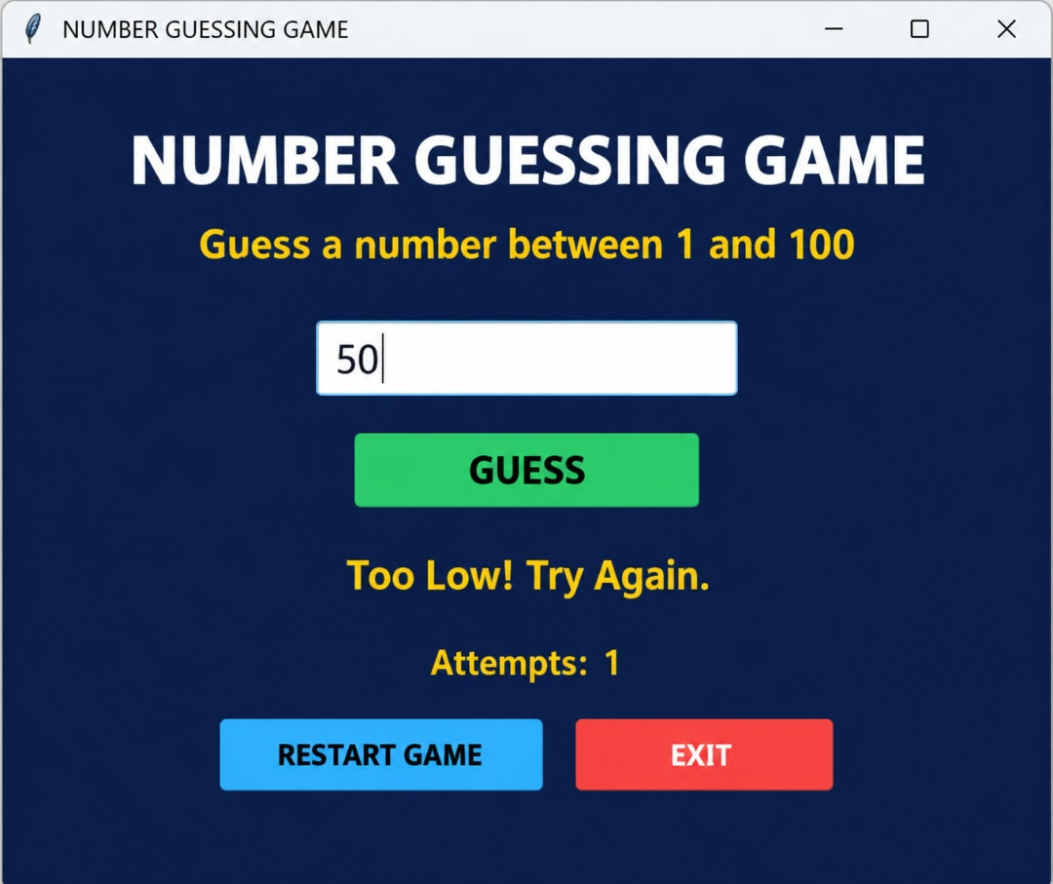

RESULT:
Thus, an interactive Number Guessing Game was developed using Python Tkinter with a graphical interface, random number generation, user input validation, hint messages, attempt counting, restart functionality, and exit controls. The program demonstrates GUI design, conditional statements, exception handling, random number generation, and basic game development concepts.

